**3. AI Multimedia Generating Tools**

**3.1 Overview**

AI multimedia tools refer to artificial intelligence systems designed to automate or assist in the creation of various media types, including text, images, audio, video, animation, and interactive content.  
Multimedia, in general, combines multiple forms of content—such as text, images, audio, and video—into a unified presentation to create richer and more engaging user experiences. Interactive multimedia enables active user participation through features like clickable elements, quizzes, and games, making content more dynamic and personalized.  
With advancements in AI, content generation has evolved significantly. Natural Language Processing (NLP) enables AI to produce structured and coherent textual content, such as articles, reports, and blog posts. Generative Adversarial Networks (GANs) and other generative models facilitate the creation of realistic images, while AI-driven tools support music composition, sound editing, voice synthesis, video production, and animation. Collectively, these innovations reduce manual workload, enhance creative efficiency, and enable personalized multimedia experiences.  
**Reference:** Wikipedia, *Multimedia*; AIPLUSINFO, *AI’s Influence on Media and Content Creation*

**3.2 Text-to-Text Generation Models**

Text-to-text AI models, such as ChatGPT, generate coherent text from natural language prompts and have significant educational implications. These tools enable rapid production of essays, code, and assignments, raising concerns about academic integrity as students may submit AI-generated work without learning.

ChatGPT uses transformer architecture to maintain context and produce fluent responses but can also generate incorrect or fabricated information, including fake academic references. Traditional plagiarism detection tools struggle to identify such content.

Digital watermarking has been proposed as a detection method, embedding hidden patterns in AI-generated text to enable identification. However, this approach is not foolproof, as students can alter the text to avoid detection, and access to detection tools may be limited.

To address these challenges, institutions should develop flexible policies, provide training for students and staff on ethical AI use, and redesign assessments to reduce misuse. Human judgment remains crucial for detecting AI-generated content. Engaging students in policy-making and adopting a collaborative community approach are essential to maintaining academic integrity in the AI era.

**3.3 Text-to-Image Models**

Text-to-image models are AI systems capable of generating images directly from natural language descriptions. They bridge linguistic and visual modalities, enabling users to produce visuals that align with specific prompts.  
Current approaches include:

1. **Generative Adversarial Networks (GAN-based)** – Utilizes a generator–discriminator framework to produce realistic images that align with text descriptions.
2. **Diffusion Models** – Gradually transform noise into coherent images using denoising steps guided by the prompt; exemplified by *Stable Diffusion* and *DALL·E 2*.
3. **Transformer-based Models** – Leverage transformer architectures to model relationships between text and visual components, allowing fine-grained image control.
4. **Hybrid Approaches** – Combine multiple techniques to maximize both visual quality and semantic accuracy.  
   Applications include digital art, marketing, product design, and educational content creation.  
   **Reference:** arXiv, *Text-to-Image Generation Models*

**3.4 Text-to-Audio/Voice Models**

These AI systems generate speech, music, or sound effects from textual input, enabling applications like voice assistants, audiobooks, and music composition. Examples include Google WaveNet and Uber’s Jukebox.

**3.5 Text-to-Video Models**

Emerging AI tools create video content from text descriptions or minimal inputs, automating video production aspects. Though still developing, platforms like Runway Gen-2, Meta’s Make-A-Video, and Google’s VEO 3 demonstrate early capabilities.

**3.6 Use Cases in Education**

Text-to-image models can enhance education by producing rich, context-specific visual materials tailored to various learning styles, improving comprehension and engagement.

* **Educators** can create custom illustrations, diagrams, and infographics aligned with lesson objectives, reducing the need for manual design.
* **Students** can visualize abstract concepts, historical events, and scientific processes, aiding retention and fostering creativity.
* **Creative Fields** such as art, design, and media studies can integrate these tools into coursework to inspire innovation and develop visual communication skills.
* **Inclusive Education** benefits through culturally relevant and accessible imagery adapted for different linguistic contexts and students with disabilities.  
  Overall, these models bridge the gap between abstract concepts and tangible understanding.

Diagram: (Student AI Usage Statistics – Digital Education Council Global AI Student Survey, 2024)

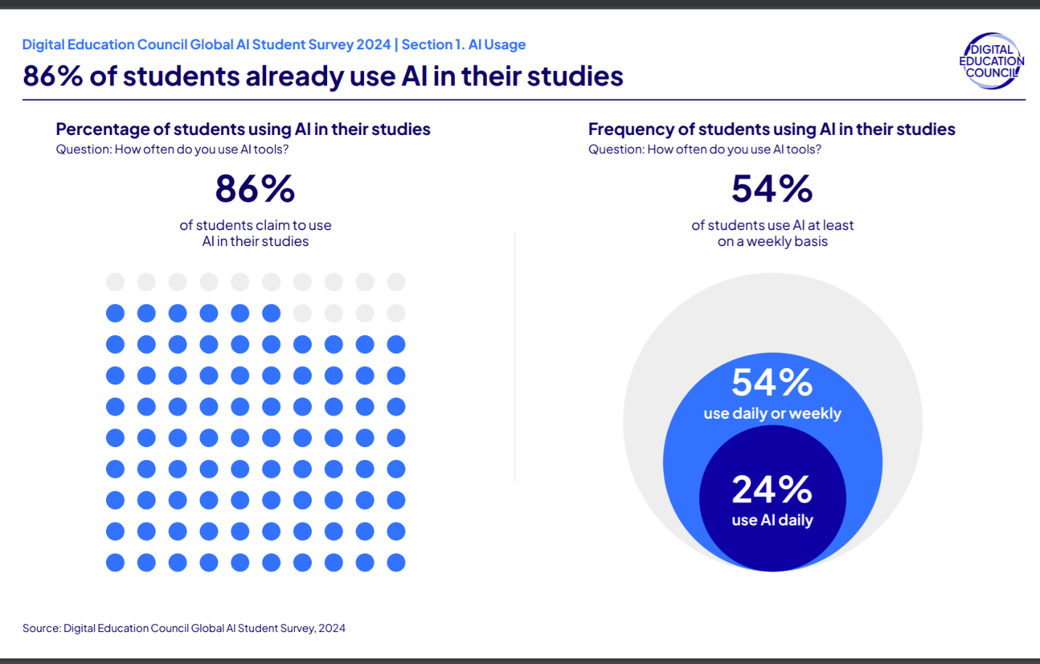

* **86%** of students already use AI in their studies.
* **54%** use AI daily or weekly, with **24%** using it daily.  
  This indicates AI is a mainstream tool in modern learning environments.

**Diagram: (Future AI Use in Classrooms – Forbes)**

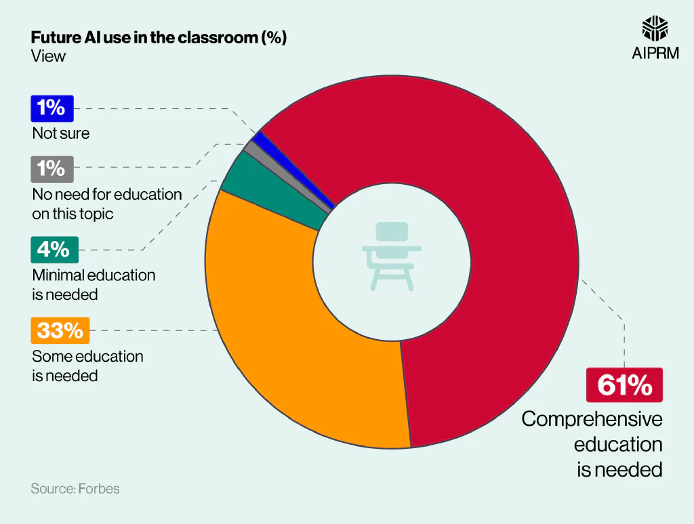

* **61%** believe comprehensive AI education is necessary.
* **33%** believe some education is needed.
* **4%** believe minimal education is needed.
* **1%** see no need; **1%** are unsure.  
  This reflects strong consensus on the need for AI literacy in education.

**3.7 Challenges and Ethics**

Despite the promising capabilities of AI multimedia tools, several significant challenges and ethical concerns must be addressed to ensure their responsible use.

One major challenge involves the **quality and reliability** of AI-generated content. Models sometimes produce inaccurate, biased, or misleading outputs, which can affect the credibility of educational materials or media productions. These errors may arise from biased training data or inherent model limitations.

**Bias and fairness** constitute another critical issue. AI systems often reflect societal prejudices present in their datasets, risking the perpetuation of stereotypes or discrimination, particularly in culturally sensitive content. This concern is especially relevant in educational contexts where inclusivity and equity are paramount.

**Copyright and intellectual property rights** also pose challenges. The generation of images, videos, or music by AI may inadvertently infringe upon existing works, raising legal and ethical questions regarding ownership and proper attribution. Clear guidelines and regulations are still evolving in this area.

Moreover, the misuse of AI tools for **creating deceptive content**, such as deepfakes or fabricated news, threatens trust and can lead to misinformation. This necessitates the development of robust detection methods and ethical standards to mitigate harm.

Finally, issues of **data privacy** and **user consent** arise when AI models are trained on or utilize personal or sensitive information, calling for transparent data practices and compliance with regulations like GDPR.

Addressing these challenges requires multidisciplinary collaboration between technologists, educators, policymakers, and ethicists to establish frameworks promoting transparency, accountability, and fairness in AI multimedia applications.

**3.8 Summary**

AI multimedia generating tools are transforming how content is created, distributed, and consumed. From text-to-image applications enhancing classroom learning to predictive models shaping personalized media experiences, these technologies offer vast potential but also require ethical consideration. Their integration into education not only improves efficiency and creativity but also raises the need for comprehensive AI literacy.

**References**

1. Alsmadi, I., & Almarashdeh, I. (2023). *Artificial intelligence applications in education: A review of current trends and future perspectives*. *Education and Information Technologies*, 28(4), 4513–4532. <https://doi.org/10.1007/s10639-022-11298-4>
2. Chen, Y., & Wang, X. (2022). Enhancing learning engagement through AI-assisted content creation. *Computers & Education*, 181, 104453. <https://doi.org/10.1016/j.compedu.2022.104453>
3. Kovačević, A., & Li, J. (2023). The role of generative AI in personalized education. *British Journal of Educational Technology*, 54(5), 1290–1307. <https://doi.org/10.1111/bjet.13315>
4. Zhang, M., & Lee, D. (2021). Artificial intelligence for multimedia-based education: Opportunities and challenges. *Interactive Learning Environments*, 29(7), 1132–1149. https://doi.org/10.1080/10494820.2019.1703012
5. UNESCO. (2023). *Guidance on the ethical use of artificial intelligence in education*. Paris: UNESCO Publishing. <https://unesdoc.unesco.org>
6. Hao, K. (2019). AI is sending people to jail—and getting it wrong. *MIT Technology Review*. <https://www.technologyreview.com/2019/01/21/137783/ai-is-sending-people-to-jail-and-getting-it-wrong/>